Diseases caused by bacteria Name:_________________________
 |  | Symptoms | How is it spread | How can you avoid spreading it to others or avoid catching it?
Whooping cough | 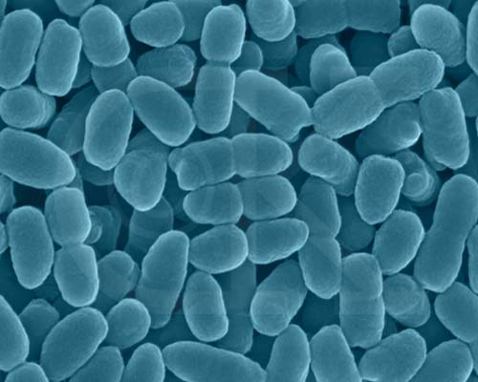
Tetanus | 
Impetigo (school sores) | 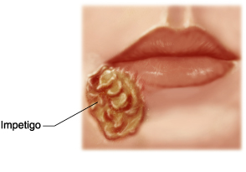
Pnuemococcal | 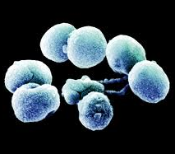
Meningococcal | 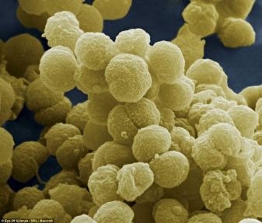
Typhoid | Who was Typhoid Mary?  

